**Documentation**

**FreeBook: A digital book bank**

**1.PROJECT OVERVIEW:**

**1.1 PROJECT NAME: FREEBOOK[A DIGITAL BOOK BANK]**

**1.2 OBJECTIVE AND GOALS:**

FreeBook is a digital platform designed to facilitate the book exchange among its users. It aims to provide a convenient and efficient way for individuals to access a wide range of books free of cost. Our aim is to promotes free education as much as possible and helps the needy student by donating book .

The goal of FreeBook is to create a comprehensive digital book bank that offers users a wide range of books at no cost. This platform will enable users to borrow, read, and contribute books in a user-friendly and efficient manner. The system must ensure the availability of diverse content while managing copyright issues, maintaining high availability, and providing a seamless user experience.

**1.3 STACKHOLDERS AND TEAM MEMBERS:**

* Stackholders: General Public,Researchers,Educators,Students,Book Enthusiasts ,Teachers,Administrators etc.
* Team-Members:Chandan Kumar(Solo).

**2. INTRODUCTION:**

* 1. **BACKGROUND AND CONTEXT**

**2.1.1. Background:**

In the modern era, access to educational resources and literature is crucial for personal development and academic success. Despite the increasing availability of digital content, many individuals still face barriers in accessing quality books due to high costs, limited availability, or geographic constraints. FreeBook aims to address these issues by providing a platform where users can access a vast library of digital books for free.

**2.1.2.Context:**

* **Project Vision**

- Mission: FreeBook aims to democratize access to reading materials by providing a platform where users can access a wide range of eBooks and audiobooks for free or at a minimal cost. The platform will focus on making educational and literary resources available to a diverse audience.

- Vision: To become a leading digital book bank that supports lifelong learning, personal development, and cultural enrichment by offering a comprehensive and accessible library of digital content.

* **Target Audience**

- Students and Educators: Providing educational resources and textbooks to support learning and teaching.

- General Readers: Offering a diverse collection of fiction, non-fiction, and literary works for recreational reading.

- Researchers: Supplying academic and reference materials to support research and scholarly work.

- Libraries and Institutions: Partnering with libraries and educational institutions to enhance their digital resources.

* **Goals and Objectives**

- Accessibility: Ensure the platform is accessible to users with different needs and devices.

- Content Diversity: Build a rich and varied collection of digital books and audiobooks.

- User Experience: Create an intuitive and user-friendly interface that makes discovering and accessing books easy.

- Community Engagement: Foster a community of readers through features like reviews, ratings, and recommendations.

* **Challenges and Considerations**

- Content Licensing: Securing the rights to digital books and audiobooks can be complex and may require negotiations with publishers and authors.

- User Privacy and Data Security: Implementing robust security measures to protect user data and comply with data protection regulations.

- Monetization and Sustainability: Developing a sustainable business model that supports the platform’s operations while keeping access affordable.

* **Strategic Importance**

- Educational Impact: By providing free or low-cost educational resources, FreeBook can contribute to educational equity and support lifelong learning.

- Cultural Enrichment: Facilitating access to a wide range of literary works promotes cultural and intellectual growth.

- Market Positioning: Establishing FreeBook as a leading digital book bank can differentiate it from existing commercial platforms and fill a niche in the digital content market.

**2.2 PROBLEM STATEMENTS**

**Problem Statement 1:**

Develop and implement features that enhance accessibility, including screen reader compatibility, adjustable text sizes, and a user-friendly interface that simplifies navigation for all users.

**Problem Statement 2:**

Develop a robust system for managing digital rights, including mechanisms for licensing agreements, digital rights management (DRM), and compliance with copyright laws.

**Problem Statement 3:**

Design and implement a scalable architecture that supports high performance, efficient data management, and reliable access to digital books.

**Problem Statement 4:**

Develop a content curation strategy and quality control processes to ensure that all digital books meet high standards of formatting, accuracy, and relevance.

**Problem Statement 5:**

Design and implement comprehensive security measures to protect user data, prevent unauthorized access, and ensure the integrity of digital content.

**2.3PROJECT SIGNIFICANCE AND BENEFITS**

* + **SIGNIFICANCE:**

**1. Promoting Educational Equity:**

FreeBook plays a crucial role in making educational resources more accessible to a broader audience. By offering a wide range of digital books for free, it helps bridge the gap between different socioeconomic groups, providing equal opportunities for learning and development regardless of financial constraints.

**2. Supporting Lifelong Learning:**

Access to diverse literature and educational materials fosters lifelong learning. FreeBook supports continuous education by offering books on various subjects, enabling users of all ages to expand their knowledge and skills at their own pace.

**3. Encouraging Reading Culture:**

By providing a user-friendly platform with a vast selection of books, FreeBook encourages a culture of reading. Increased access to literature can inspire a love for reading and promote intellectual curiosity among users.

**4. Reducing Environmental Impact:**

Digital books reduce the need for physical copies, thus minimizing paper waste and the carbon footprint associated with traditional book production and distribution. FreeBook contributes to a more sustainable approach to accessing literature.

**5. Facilitating Research and Academic Work:**

Researchers, students, and academics benefit from easy access to a wide range of academic texts and reference materials. FreeBook supports academic success by providing valuable resources for research and study without the burden of high costs.

* + **BENEFITS:**

**1. Cost Savings:**

Users can access a vast library of digital books at no cost, saving money on purchasing or renting physical books. This is particularly beneficial for students, educators, and readers who may not have the financial means to buy books.

**2. Convenience and Accessibility:**

FreeBook provides the convenience of accessing books anytime and anywhere, using various devices such as smartphones, tablets, and computers. This flexibility enhances the reading experience and makes it easier for users to integrate reading into their daily lives.

**3. Diverse Content:**

**The platform offers a broad range of books across multiple genres and topics, catering to diverse interests and reading preferences. This diversity ensures that users can find books that match their individual tastes and needs.**

**4. Enhanced Learning Tools:**

FreeBook can include features like adjustable text sizes, highlighting, note-taking, and search functionality, which enhance the learning and reading experience. These tools support active engagement with the content and facilitate better comprehension and retention.

**5. Community Engagement:**

The platform can foster a community of readers through features like book reviews, ratings, and discussion forums. This engagement allows users to share recommendations, participate in discussions, and connect with others who have similar interests.

**6. Continuous Improvement:**

By incorporating user feedback and analytics, FreeBook can continuously evolve to meet the needs of its users. This iterative improvement ensures that the platform remains relevant, user-friendly, and effective in providing high-quality content.

**7. Educational Support:**

Educators can leverage FreeBook as a resource for supplemental reading materials and classroom resources. The availability of educational content supports teaching and enhances the learning experience for students.

**8. Global Reach:**

Digital books can be distributed globally, allowing users from different geographic locations to access content without the limitations of physical distribution. This global reach helps in making valuable resources available to a wider audience.

**3.REQUIREMENTS:**

**3.1. Functional Requirements**

* **Book Repository:** A searchable database of eBooks and audiobooks.
* **User Management:** Registration, login, and profile management.
* **Search and Filtering:** Advanced search options, categories, and filters.
* **Book Access:** Options for reading online, downloading, and streaming.
* **Recommendations:** Personalized book recommendations based on user preferences and reading history.
* **Reviews and Ratings:** User reviews and ratings for books.
* **Bookmarking:** Save reading progress and favorite books.
* **Support:** Helpdesk and FAQ section for user assistance.
* **Data Security:** Secure handling of user data and book content

**3.2. Non-Functional Requirements**

* **Performance:** Fast loading times and responsive design.
* **Scalability:** Ability to handle a growing number of users and books.
* **Compatibility:** Access across various devices and browsers.
* **Accessibility:** Compliance with accessibility standards.

**4.** **ARCHITECTURE AND DESIGN**

* 1. **System Architecture Diagram**

**Desktop View Design**

P.T.O

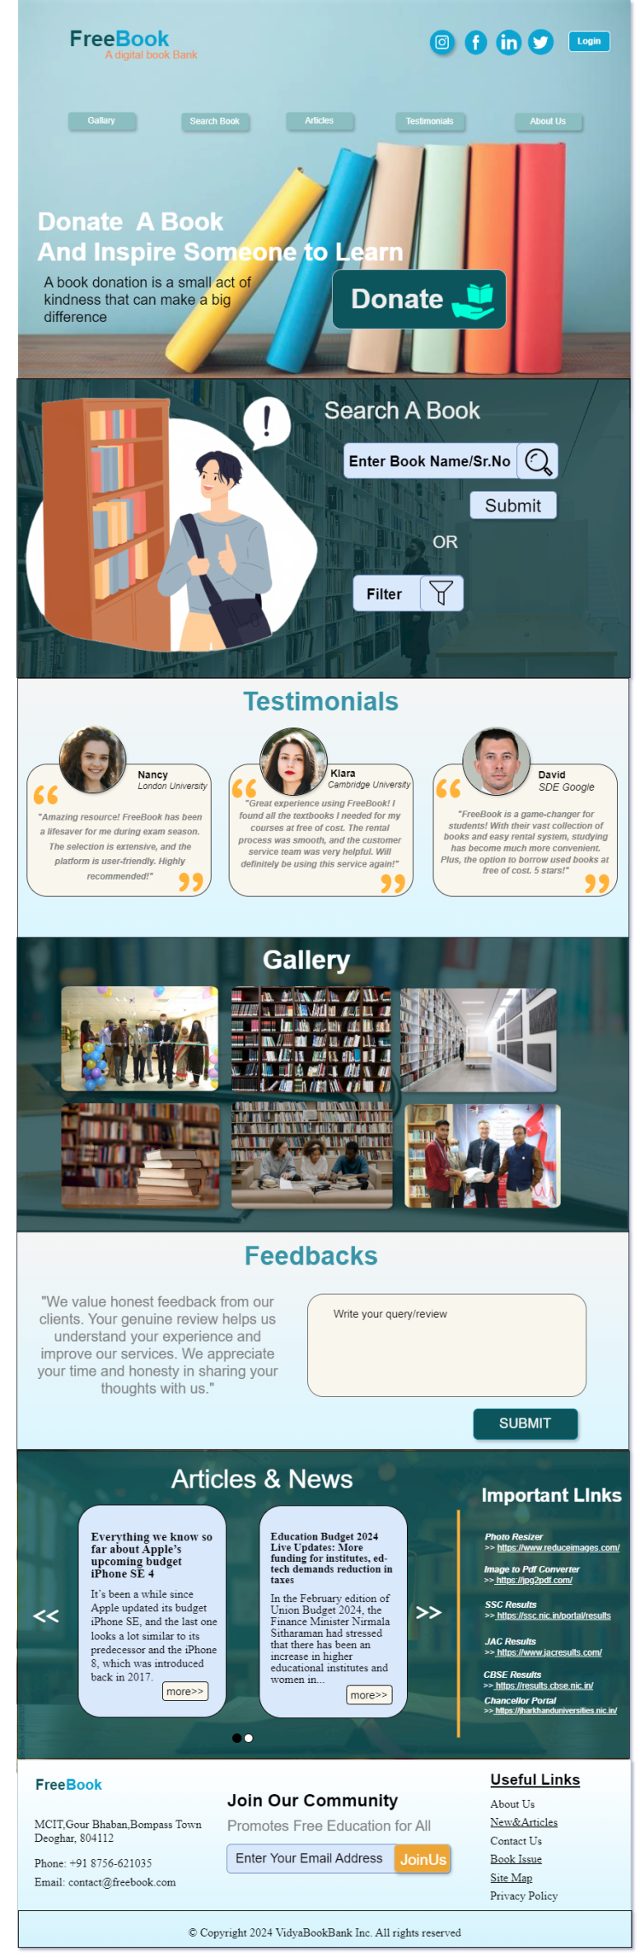

**Mobile View Design**

P.T.O.

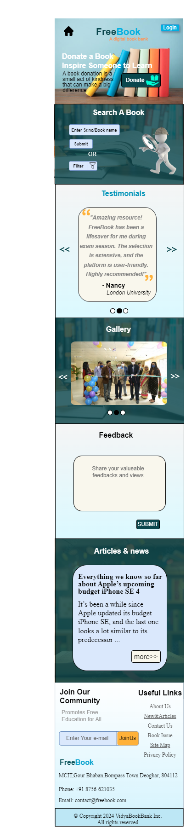

* 1. **ERD**

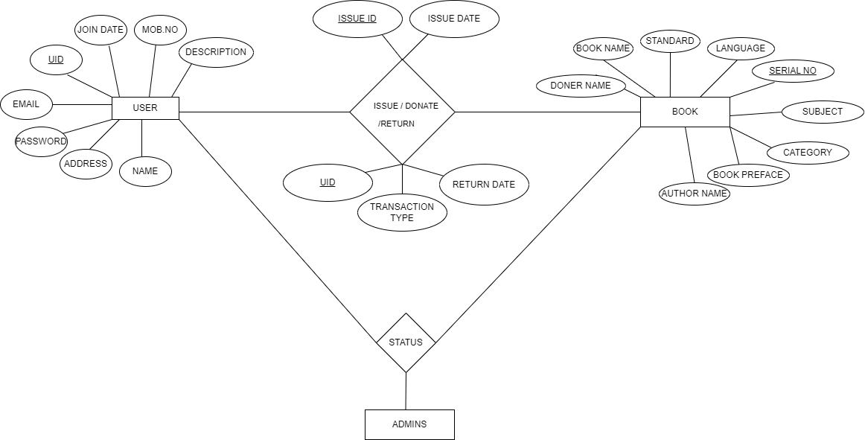

* 1. **DFD**

**LEVEL-0**

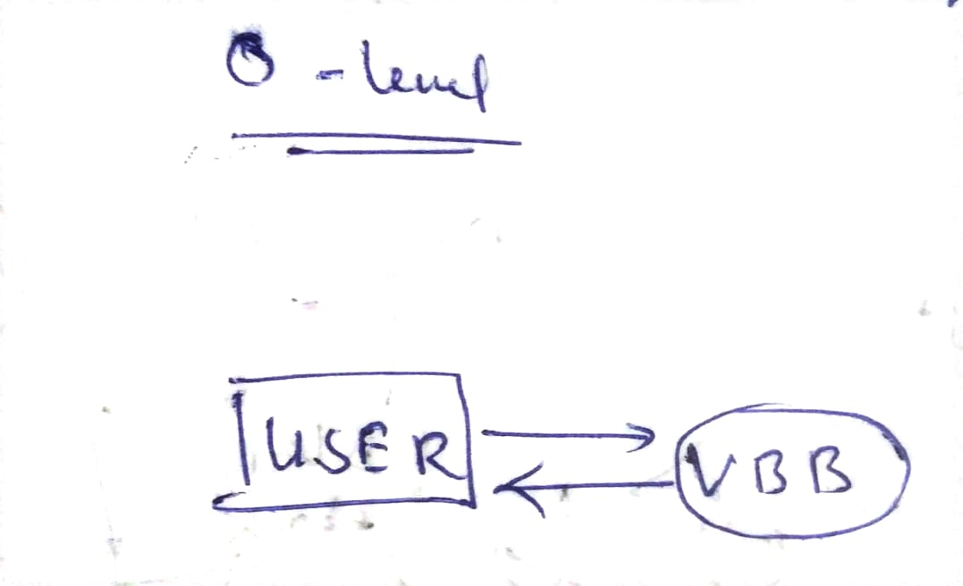

**LEVEL-1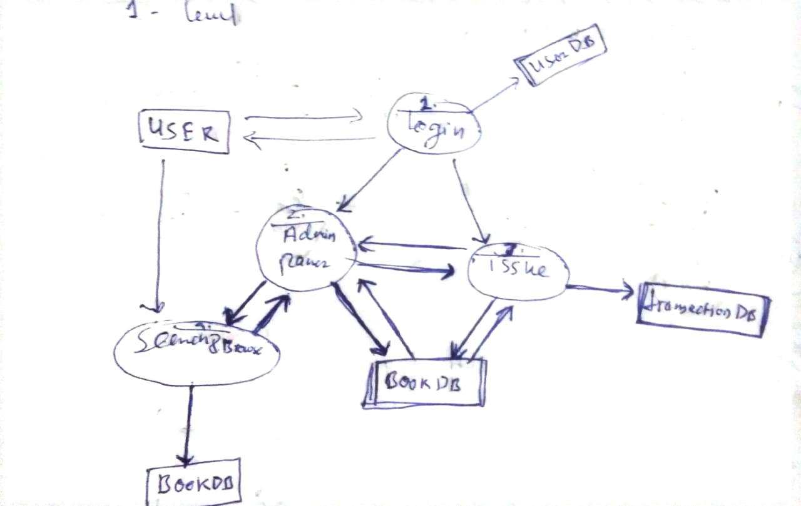 LEVEL-2**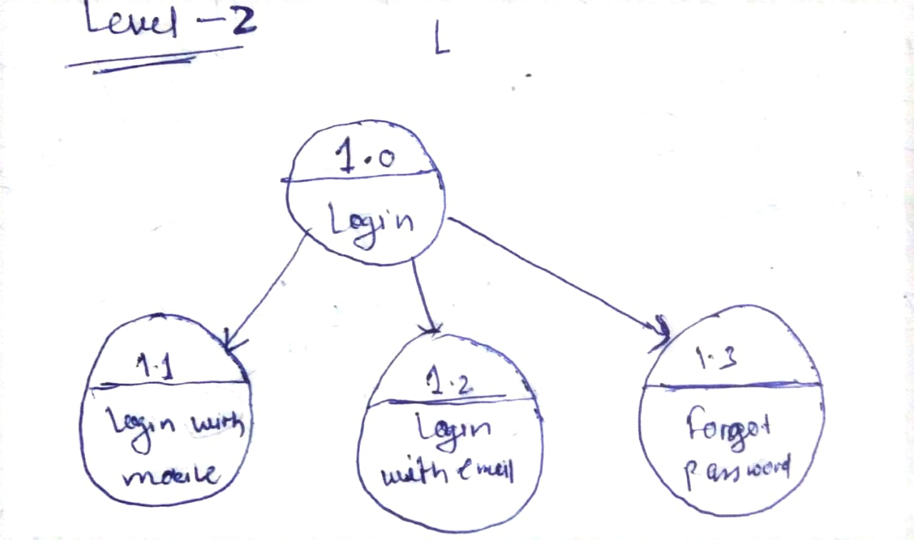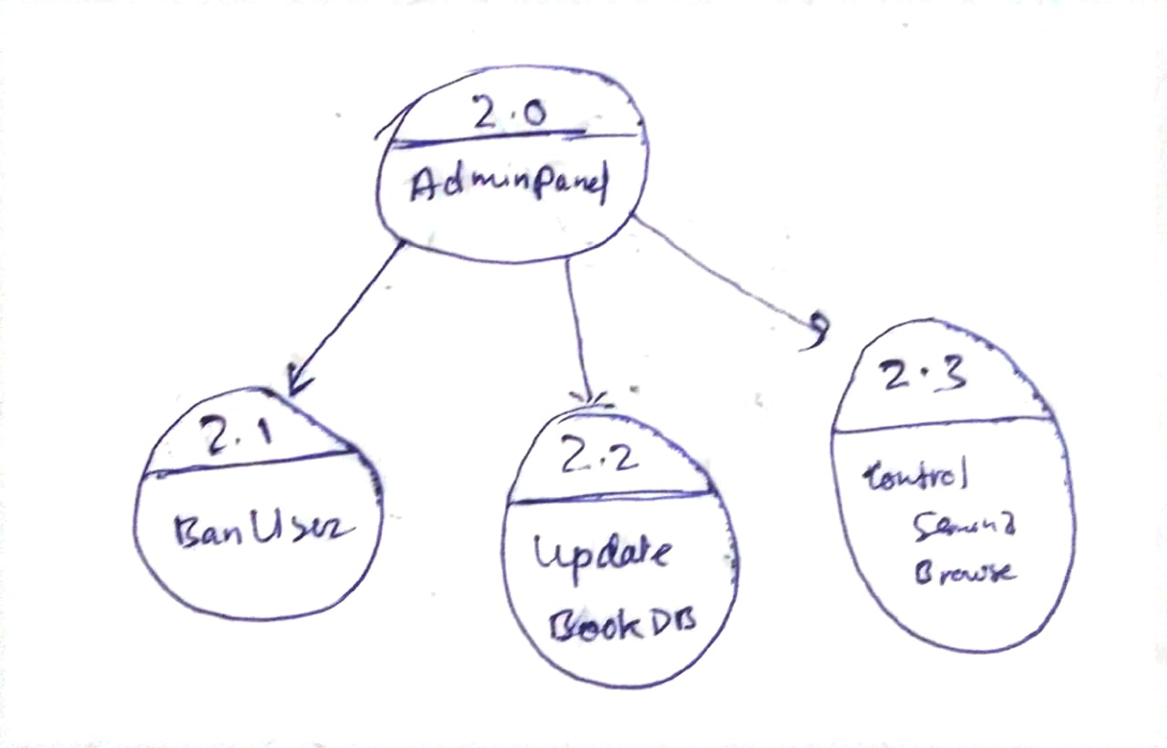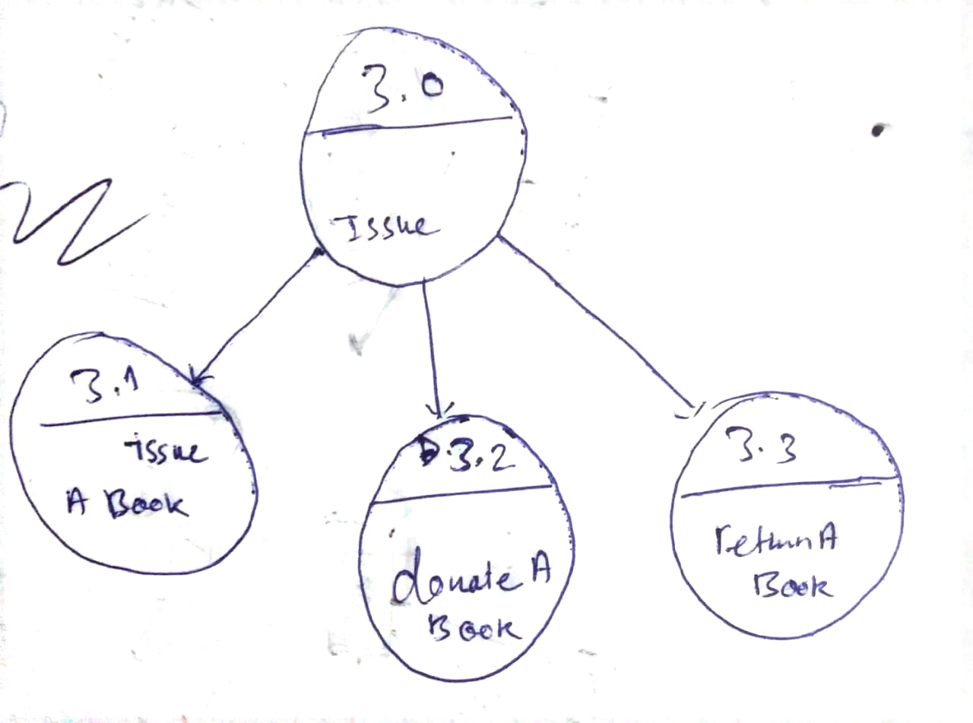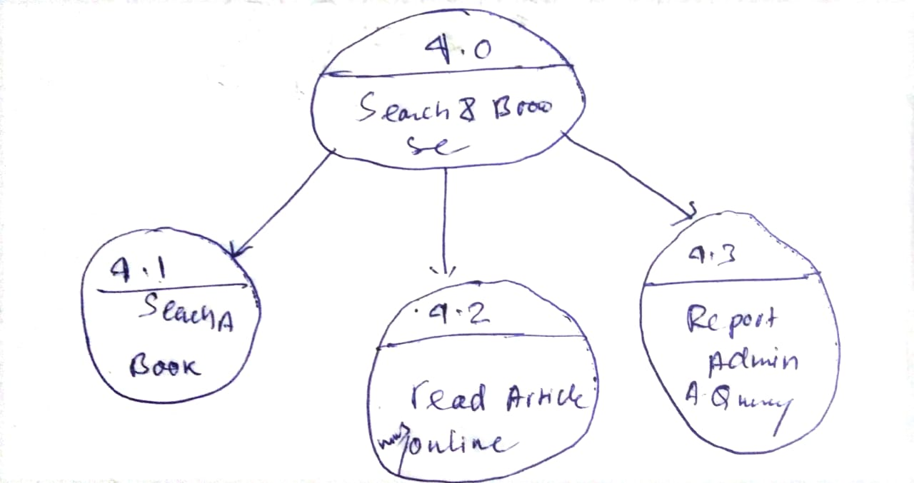

**8.USER GUIDE**

**8.1 User Guide**

**Registration and Login**

- New users must register with their email address and create a password.

- Upon registration, users can log in using their credentials.

**Finding Books**

- Users can search for books using serial number,bookname, keywords, author names, or categories.

- Filters help narrow down search results based on preferences.

**Borrowing Books**

- Users can to borrow available books from FreeBook and request for not available books.

- Borrowing terms, including lending periods and conditions, are displayed before confirmation.

**Reading Books**

- Borrowed books can be accessed through the user's account.

- The reading interface allows for customization of reading preferences.

**Returning Books**

- Users must return borrowed books within the agreed-upon lending period.

- Late returns may incur penalties set by the VBB.

**Leaving Reviews**

- After reading a book, users can leave reviews and ratings based on their experience.

**8.2 Administrator Guide**

**Managing Users**

- Admins can add, modify, or deactivate user accounts.

- User data management ensures compliance with privacy policies.

**Managing Books**

- Admins oversee the catalog, adding new books and updating existing listings.

- Book statuses, such as availability and lending conditions, are managed through the admin panel.